Steps to create new user and assign groups:

1. Open the Application manager for the required environment and open Application Platform

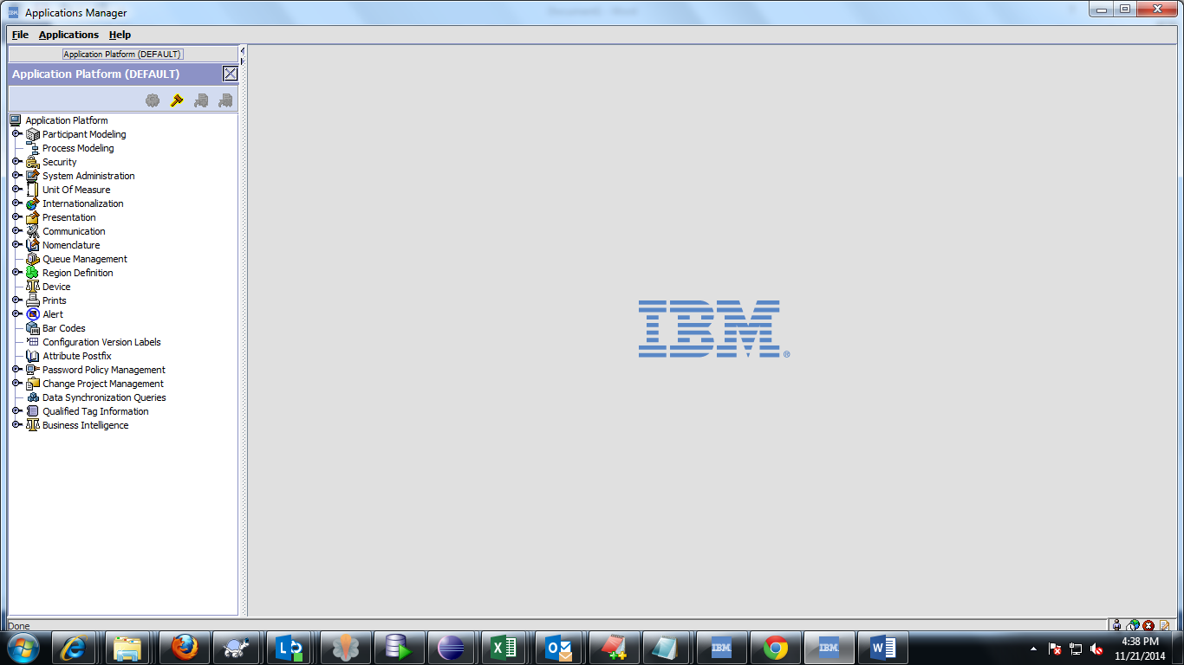

1. Under Application platform double click security option and double click on users

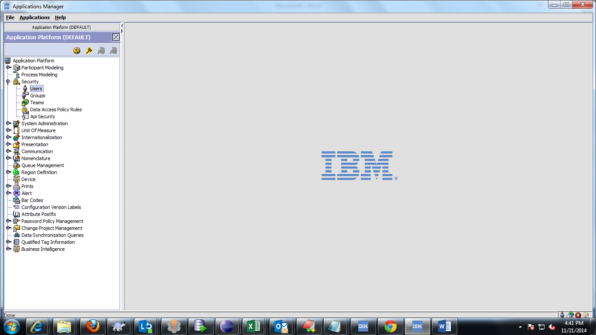

1. In the Search Results pane click on create icon 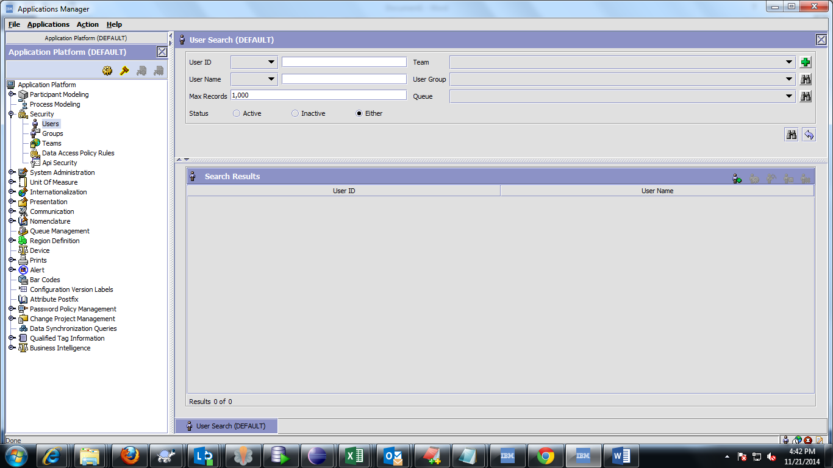
2. Enter the user_id, user_name and password and the locale based on the requirements

Select the required group under the group subscriptions and subscribe to the required groups

For example, We have subscribed “HP-CUST-SERVICE-SPANISH” to the user. Please don’t follow the same, subscribe the user groups as given by Business.

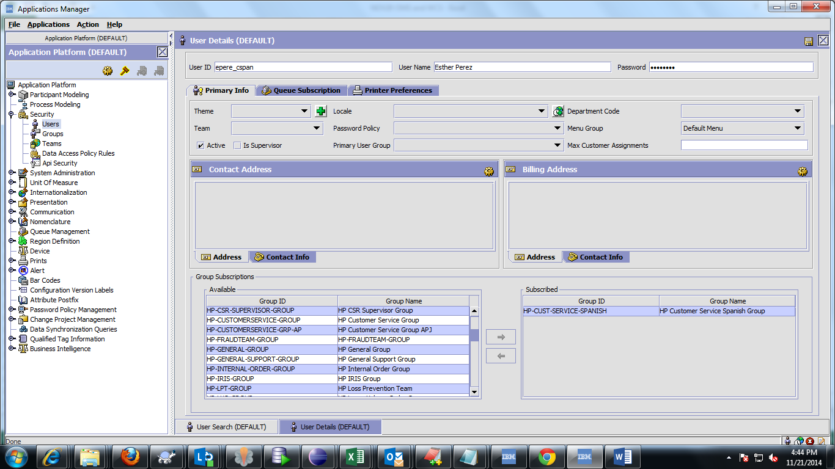

1. Click on details icon in the contact address pane and fill the required fields and click OK

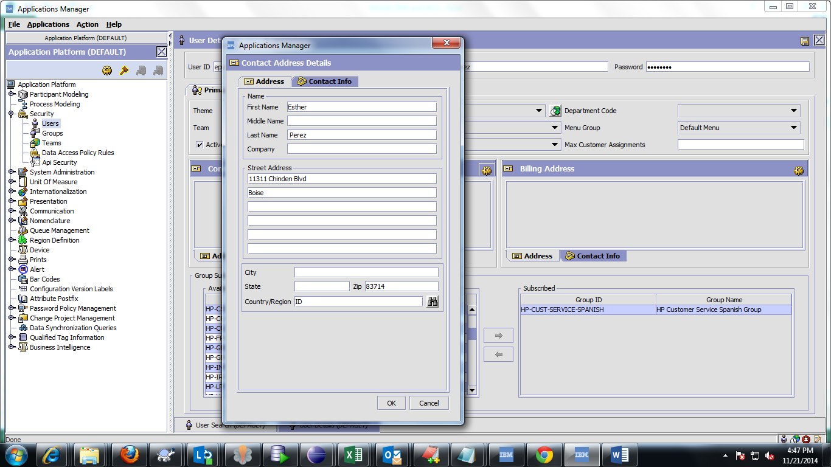

1. Click on Save

